Didcot Town Council

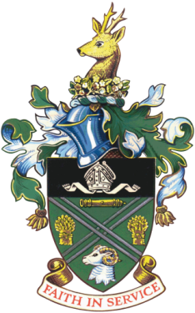

**Didcot Town Council Awards Nomination Form (new)**

If you would like to nominate somebody for one of the Didcot Town Council Awards, please complete this application form. Please tick appropriate award.

The Awards Categories are:

|  |  |
| --- | --- |
|  | **Didcot Artistic Award** |
|  | For people who have made a contribution to the artistic or cultural life in Didcot |
|  |  |
|  | **Sporting Achievement Award** |
|  | For those individuals, pairs, clubs, or teams who have made a significant contribution to sport |
|  |  |
|  | **Service with a Smile Award** |
|  | This is for people who take pride in their work and make our days better when we see them |
|  |  |
|  | **Young Volunteer or Charity Fundraiser (under 21) Award** |
|  | This is for young people who deserve recognition for volunteering regularly or have raised money for charity |
|  |  |
|  | **Lifetime Achievement Award** |
|  | This is for people who have gone that extra mile during their working career |
|  |  |
|  | **Unsung Hero Award** |
|  | This is for those people who work incredibly hard for the community with little recognition – nominations need not be for volunteering only |
|  |  |
|  | **Environmental Award (new)** |
|  | To recognise residents or groups that make a positive environmental contribution to the local environment |
|  |  |
|  | **John Eldridge Award** |
|  | This is for those people who have diligently served the local community through voluntary service | |

**Nominee Details** (as much as possible)

|  |  |
| --- | --- |
| Nominee name: |  |
| Nominee contact number: |  |
| Nominee email address: |  |
| Nominee address: |  |
|  |  |
| Description of nominee’s achievements and why you have nominated them: | |
|  | |
|  | |
|  | |
|  | |
|  | |
|  | |
|  | |
|  | |
|  | |
|  | |

**Your Details**

|  |  |
| --- | --- |
| Your name: |  |
| Your contact number: |  |
| Your email address: |  |
| Your address: |  |
|  |  |

Completed forms should be returned to: Town Council Offices, Britwell Road, Didcot, Oxon

OX11 7HN or email the form to [events@didcot.gov.uk](mailto:events@didcot.gov.uk) by Thursday 30th November 2023.