**DIDCOT CIVIC HALL**

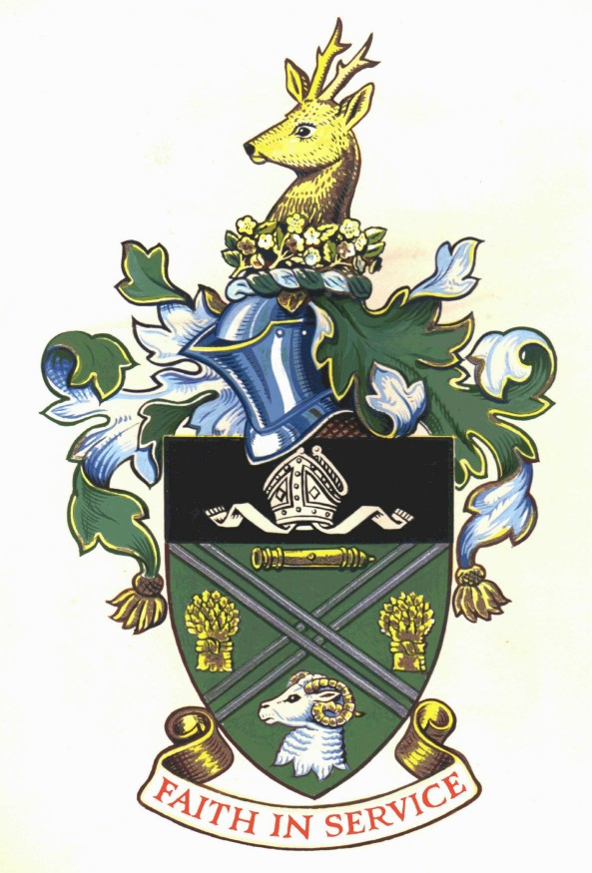

**Event Bar Staff**

**Salary Scale Point 5 £21,575 pro rata or £11.21 per hour (Pending national pay review)**

**or**

**Salary Scale Point 6 with a licence to serve alcohol £21,968 pro rata or £11.42 per hour (Pending national pay review)**

**Casual Contract – variable hours**

Didcot Town Council is seeking to recruit several passionate and enthusiastic bar staff to support events at the Didcot Civic Hall. We are looking for hard working bar staff that are hard working that can serve a range of alcoholic and non-alcoholic drinks in volume at busy events.

This role will be on a casual basis with events mainly taking place on evenings and weekends on a rota, but some weekday work can be available.

Previous experience is desirable but not essential as training will be given if you have the passion and enthusiasm for working in a bar.

**An application form and further details can be obtained from Didcot Town Council, Britwell Road, Didcot, Oxfordshire OX11 7JN, telephone 01235 812637 or email** [**council@didcot.gov.uk**](mailto:council@didcot.gov.uk)**, or via the website at** [**www.didcot.gov.uk**](http://www.didcot.gov.uk)

**Completed applications may be emailed to** [**smundy@didcot.gov.uk**](mailto:smundy@didcot.gov.uk)

**The closing date is open ended until all roles are filled. Interviews for shortlisted candidates will be held at the earliest possibility.**

***Didcot Town Council is committed to Equality of Opportunity and actively welcomes applications from all sections of the community.***