Didcot Town Council

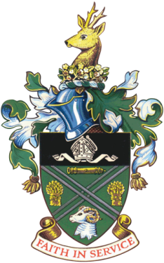

|  |
| --- |
| May 2023 |

|  |
| --- |
| TO WHOM IT MAY CONCERN |

|  |
| --- |
| **DIDCOT TOWN COUNCIL NO LONGER RESPONSIBLE FOR CUTTING VERGES**  **Didcot Town Council’s historic agreement with Oxfordshire County Council (OCC) to manage the cutting of the grass verges came to an end from 31st March 2023.**  **OCC will resume responsibility for this service from April 2023 and will only carry out ONE cut per year. We believe this will be from June onwards but have no further information.**  ***Please be advised that land belonging to Didcot Town Council will continue to be cut as normal including all the parks and recreation grounds. Similarly land belonging to the District Council will continue to receive its normal cuts*.**  **Any Didot resident who is unhappy with the grass cutting on verges owned by Oxfordshire County Council should address their complaints to:** [**grasscutting@oxfordshire.gov.uk**](mailto:grasscutting@oxfordshire.gov.uk) |

|  |
| --- |
| Mrs J Wheeler  Town Clerk and Responsible Finance Officer |