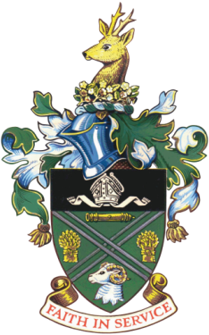

Didcot Town Council

**21 April 1926 – 8 September 2022**

**Her Royal Highness, Her Majesty Queen Elizabeth II**

Didcot Town Council would like to express our deepest condolences to members of the Royal Family on the passing of Her Majesty the Queen. Her Royal Highness was totally devoted to her country and her people. She will be missed.

We are sure that the residents of Didcot will wish to share their sorrow and come together to mark this sad occasion; to look back on her life and to give thanks for her years of dedicated service.

A Book of Condolence will be opened at the Civic Hall for residents to gather; sign the book; say prayers and share memories.

Her Royal Highness Queen Elizabeth II was one of the longest serving monarchs in history.

**May she now rest in peace.**

As a mark of respect, the Union Flag will fly at half-mast outside Didcot Civic Hall until the day of the State Funeral. There will be period on the Day of Proclamation – Friday 9th September – where the flag will be raised to mark the new King Charles III.

Cllr Pam Siggers, Mayor of Didcot

Cllr Mocky Khan, Leader of Didcot Town Council