**DIDCOT TOWN COUNCIL**

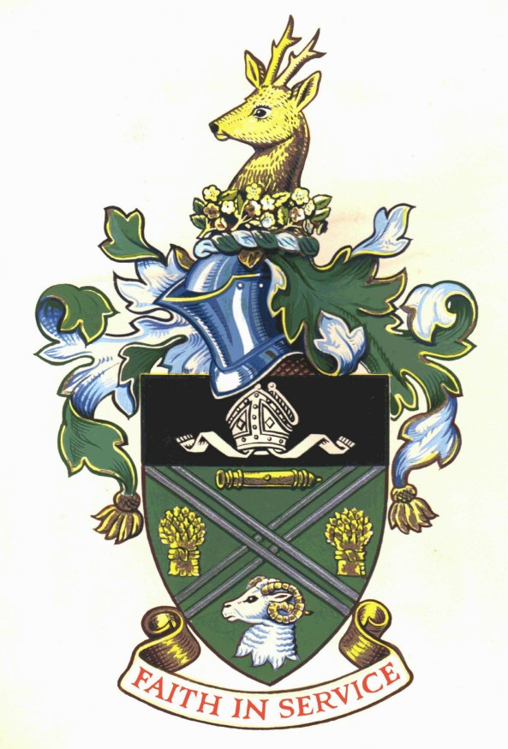

**Admin Assistant**

**Salary Scale Point 4 is £9.84**

**Working Wednesdays evenings and Sundays daytime**

Didcot is a rapidly growing and fast developing town situated in South Oxfordshire with a population of more than 27,000.

The Council is seeking to appoint a team of positive and dynamic Admin Assistants to support the evening and weekend running of the Town Councils properties, primarily the Civic Hall.

This role will involve taking bookings, answering the phone, dealing with customer enquiries, setting up spaces, Bar service, cleaning rooms ready for the next users, as well as supporting Town Council Business and events.

**An application form and further details can be obtained from Didcot Town Council, Britwell Road, Didcot, Oxfordshire OX11 7JN, telephone 01235 812637 or email** [**council@didcot.gov.uk**](mailto:council@didcot.gov.uk)**, or via the website at** [**www.didcot.gov.uk**](http://www.didcot.gov.uk)

**Completed applications may be emailed to** [**jwheeler@didcot.gov.uk**](mailto:jwheeler@didcot.gov.uk)

***Didcot Town Council is committed to Equality of Opportunity and actively welcomes applications from all sections of the community.***