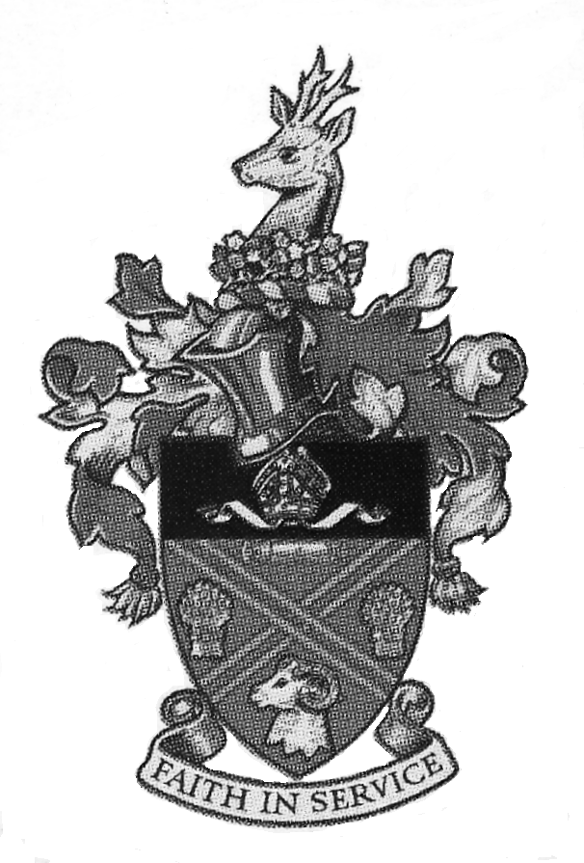

DIDCOT TOWN COUNCIL

JOB DESCRIPTION

JOB TITLE: Administrative Assistant

ACCOUNTABLE TO: Property & Facilities Manager

OBJECTIVE: To support the administrative functions of the Council and Civic Hall

JOB SUMMARY: To carry out the day-to-day duties relating to the administration of the Town Council Office and the Didcot Civic Hall.

MAIN DUTIES AND RESPONSIBILITIES:

- To support the Property & Facilities Manager in the everyday running of the Civic Hall, Town Council Building and Didcot Town Council business.

- Unlocking Opening and Closing of the buildings, as required.

- To assist with the operating and up-dating of the booking system including emails and telephone calls to hirers.

- To offer advice to potential hirers and to ensure booking forms are correctly completed. To take payments, deposits and deal with other requests where appropriate.

- To prepare rooms for hirers. To supervise large functions/hall lettings including weddings.

- To serve drinks at the bar and general bar service

- To support with serving of tea, coffee and food to bookings.

- To assist with the safety and security of the Civic Hall and Town Council offices, and other properties to ensure the building is always safe for visitors and Council staff.

- To assist with general administration tasks as directed by the Property & Facilities Manager including filing; photocopying; typing letters, reports and other forms of record-keeping.

7. To attend training courses as required.

8. Any other duties commensurate with the post that may be required by the Property & Facilities Manager.

9. Shifts will include evenings, weekends and bank holidays on a rota with other members of staff.

10. You may be required to work on other sites run by or on behalf of the town council.

PAY AND BENEFITS:
This job is on the Scale Point 4 (£9.84ph) and includes holiday accrual based on the number of hours worked.

If you meet the qualifying criteria, you will be entitled to enrol in the LGP pension scheme.

WORKING RELATIONSHIP: The role requires excellent working relationships to be maintained with other members of staff, elected Members, other Councils, local organisations, groups and community members.

July 2021

