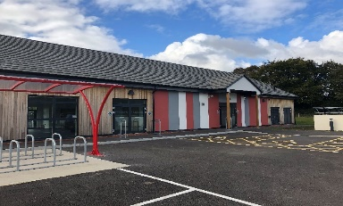

**Southern Neighbourhood Community Centre,**

**Sorrell Crescent, Great Western Park, OX11 6HQ**

**From the Civic Hall (driving) 1.5 miles**

Turn **right** onto Broadway up to the roundabout and go straight over to the Wantage Road (B4493).

Follow the Wantage Road until you reach the crossroads with the traffic lights.

Take the **Left** hand turning on to Miles E.

Take the first **Right** on to Moreland Road signposted ‘Southern Community Centre’.

Follow the road which bears around to the **Left**.

The Southern Community Centre will be on your **Right.**

**From the Civic Hall (walking/cycling) 1.2 miles**

Turn **right** onto Broadway.

Take the Wantage Road

Take the footpath on the **left** just before the Wheatsheaf, follow this for 0.5 miles.

Turn **right** to Bluebell Lane.

**Left** into Burdock Spur

Straight over to Buckthorn Crescent

**Left** onto Scots Pine Way

Straight over to Sage Drive

**Right** into Sorrel Crescent

