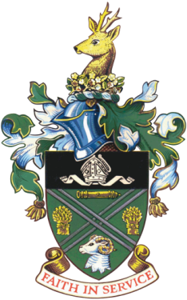

Didcot Town Council

**10th June 1921 – 9th April 2021**

**His Royal Highness Prince Philip, Duke of Edinburgh**

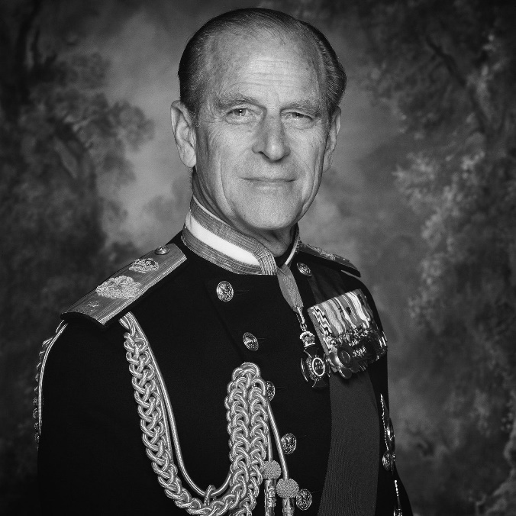

Didcot Town Council would like to join other Councils and Local Authorities across the Country in expressing our deepest condolences to Her Majesty the Queen and members of the Royal Family. His Royal Highness Prince Philip, Duke of Edinburgh passed away peacefully this morning at Windsor Castle. He was the longest serving royal consort in British history. He was also a great statesman, husband, father, grandfather, and great-grandfather. His absence will be felt by many individuals and organisations across the country.

As a mark of respect, the Union Flag will be flying at half-mast outside Didcot Civic Hall.

Didcot Town Council will join the rest of the nation in a period of mourning.

Cllr Eleanor Hards, Mayor of Didcot

Cllr Mocky Khan, Leader of Didcot Town Council