Didcot Town Council

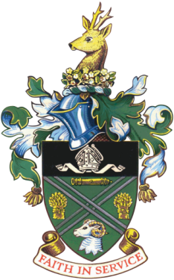

**Didcot Town Council’s Dogs on Allotments Policy**

As per section 8 of Didcot Town Council’s Allotment Rules and Procedures, whereby it states that:

***8. Dogs are allowed on the allotment sites, provided that they are well behaved and remain on a lead at all times. The plot holder is responsible for their dog and will need to make sure that any dog mess is picked up and disposed of accordingly. Dogs are not to become a nuisance to any other plot holders.***

***The Council reserves the right to retract this, should these rules not be adhered too.***

**All dogs will remain the sole responsibility of the tenant.**

**Didcot Town Council requirements for Allowing Dogs on Allotment sites**

Whilst tenants may bring their pet dogs onto the allotment they must ensure that the dog is controlled and kept on a lead at all times.

All dog fouling must be cleared immediately. Any failure to comply may result in prosecution.

The following rules **must** be adhered to:

1. All dogs must be kept on a lead at all times

2. All dogs must be well behaved

3. Dogs are not allowed to roam free on the allotments, or cause a nuisance

4. If any dog

**Should you be found to be in breach of any of these rules, the Town Council reserves the right to terminate permission of allowing livestock on your plot.**